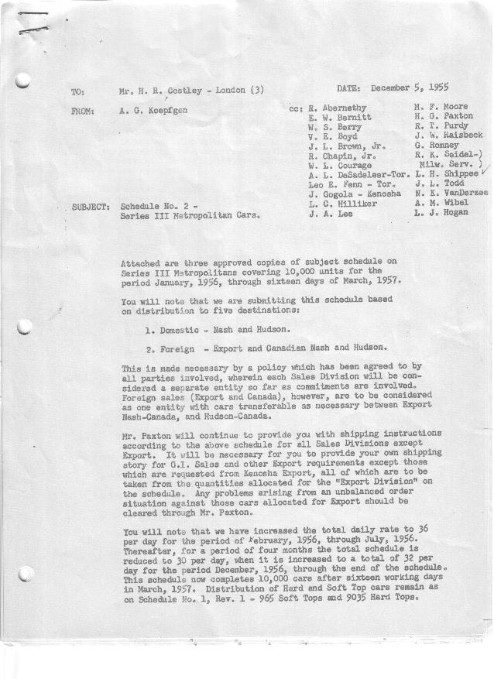

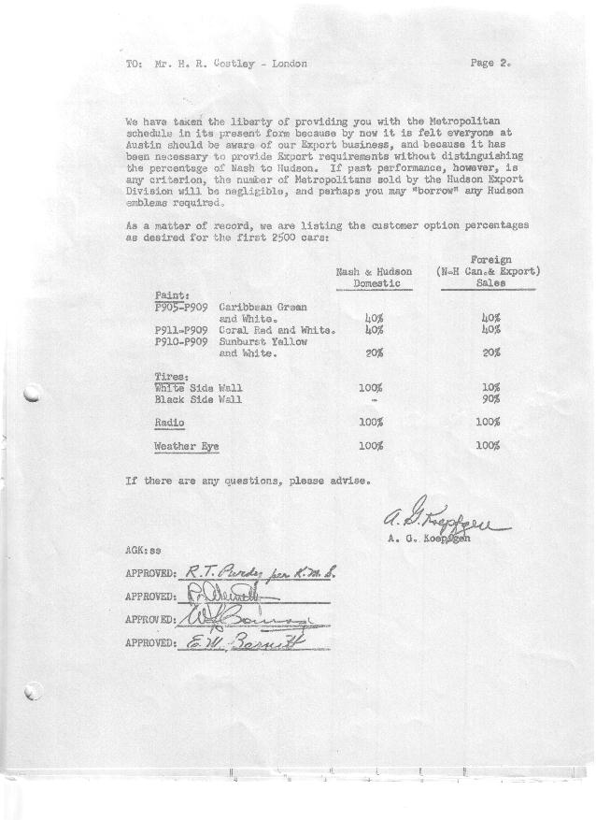

FORM PLAN 68 REV. 2-55-A.M.P Sheet 1 of 3 APPROVED R.T. Purdy & R. Abernethy (signed) DATE 12-5-55 & 12-6-55

SCHEDULE NO. ______2 ________ DATE 11-30-55 MONTHLY BUILDING SCHEDULE APPROVED W.L. Courage (signed)_ DATE_ 12-6-55 ____
REVISION NO. _______ _______ DATE PRODUCT APPROVED_E. W. Bernitt (signed) ___ __DATE 12-7-55 _ __
Series III 1500 c.c. Engine
Metropolitan Series Cars – Austin Motors Co., Ltd., England
DESCRIPTION | BUILT  ◻ACT◻ EST  THRU | FIRM BUILDING SCHEDULE  (FABRICATED MATERIAL RELEASE) |  |  |  |  |  |  |  |  |  |  |  |  |  |  | TENTATIVE SCHEDULE  (RAW MATERIAL RELEASED) |  |  | GRAND  TOTAL
DESCRIPTION | BUILT  ◻ACT◻ EST  THRU | MONTH January, 1956  DAYS 22 |  |  | MONTH February  DAYS 21 |  |  | MONTH March  DAYS 22 |  |  | MONTH April  DAYS 19 |  |  | MONTH May  DAYS 21 |  |  | MONTH June  DAYS 21 |  |  | GRAND  TOTAL
DESCRIPTION | BUILT  ◻ACT◻ EST  THRU | DAILY | MONTH | CUM’L  TOTAL | DAILY | MONTH | CUM’L  TOTAL | DAILY | MONTH | CUM’L  TOTAL | DAILY | MONTH | CUM’L  TOTAL | DAILY | MONTH | CUM’L  TOTAL | DAILY | MONTH | CUM’L TOTAL | GRAND  TOTAL
DOMESTIC:
Nash Hard-Top |  |  | 514 | 514 |  | 506 | 1020 |  | 473 | 1493 |  | 349 | 1842 |  | 403 | 2245 |  | 441 | 2686
Soft-Top |  |  | 0 | 0 |  | 50 | 50 |  | 109 | 159 |  | 100 | 259 |  | 98 | 357 |  | 45 | 402
Total Nash U.S. |  |  | 514 | 514 |  | 556 | 1070 |  | 582 | 1652 |  | 449 | 2101 |  | 501 | 2602 |  | 486 | 3088
Hudson Hard-Top |  |  | 143 | 143 |  | 135 | 278 |  | 134 | 412 |  | 146 | 558 |  | 160 | 718 |  | 154 | 872
Soft-Top |  |  | 7 | 7 |  | 15 | 22 |  | 16 | 38 |  | 14 | 52 |  | 20 | 72 |  | 26 | 98
Total Hudson U.S. |  |  | 150 | 150 |  | 150 | 300 |  | 150 | 450 |  | 160 | 610 |  | 180 | 790 |  | 180 | 970
Total U.S. |  |  | 664 | 664 |  | 706 | 1370 |  | 732 | 2102 |  | 609 | 2711 |  | 681 | 3392 |  | 666 | 4058
FOREIGN:
Export Hard-Top |  |  | 40 | 40 |  | 40 | 80 |  | 45 | 125 |  | 60 | 185 |  | 60 | 245 |  | 72 | 317
Soft-Top |  |  | 0 | 0 |  | 10 | 10 |  | 15 | 25 |  | 15 | 40 |  | 15 | 55 |  | 18 | 73
Total Export |  |  | 40 | 40 |  | 50 | 90 |  | 60 | 150 |  | 75 | 225 |  | 75 | 300 |  | 90 | 390
Canada- Nash Hard-Top |  |  | 0 | 0 |  | 0 | 0 |  | 0 | 0 |  | 0 | 0 |  | 0 | 0 |  | 0 | 0
Soft-Top |  |  | 0 | 0 |  | 0 | 0 |  | 0 | 0 |  | 0 | 0 |  | 0 | 0 |  | 0 | 0
Total Nash-Canada |  |  | 0 | 0 |  | 0 | 0 |  | 0 | 0 |  | 0 | 0 |  | 0 | 0 |  | 0 | 0
Hudson Hard-Top |  |  | 0 | 0 |  | 0 | 0 |  | 0 | 0 |  | 0 | 0 |  | 0 | 0 |  | 0 | 0
Soft-Top |  |  | 0 | 0 |  | 0 | 0 |  | 0 | 0 |  | 0 | 0 |  | 0 | 0 |  | 0 | 0
Total Hudson-Canada |  |  | 0 | 0 |  | 0 | 0 |  | 0 | 0 |  | 0 | 0 |  | 0 | 0 |  | 0 | 0
Total Foreign |  |  | 40 | 40 |  | 50 | 90 |  | 60 | 150 |  | 75 | 225 |  | 75 | 300 |  | 90 | 390
GRAND TOTALS
Hard-Top |  |  | 697 | 697 |  | 681 | 1378 |  | 652 | 2030 |  | 555 | 2585 |  | 623 | 3208 |  | 667 | 3875
Soft-Top |  |  | 7 | 7 |  | 75 | 82 |  | 140 | 222 |  | 129 | 351 |  | 133 | 484 |  | 89 | 573
Total |  | 32 | 704 | 704 | 36 | 756 | 1460 | 36 | 792 | 2252 | 36 | 684 | 2936 | 36 | 756 | 3692 | 36 | 756 | 4448

FORM PLAN 68 REV. 2-55-A.M.P Sheet #2 of #3 APPROVED R.T. Purdy & R. Abernethy (signed) DATE 12-5-55 & 12-6-55

SCHEDULE NO. ______2 ________ DATE 11-30-55 MONTHLY BUILDING SCHEDULE APPROVED W.L. Courage (signed)_ DATE_ 12-6-55 ____
REVISION NO. _______ _______ DATE PRODUCT APPROVED_E. W. Bernitt (signed) ___ __DATE 12-7-55 _ __
Series III 1500 c.c. Engine
Metropolitan Series Cars – Austin Motors Co., Ltd., England
DESCRIPTION | BUILT  ◻ACT◻ EST  THRU | FIRM BUILDING SCHEDULE  (FABRICATED MATERIAL RELEASE) |  |  |  |  |  |  |  |  |  |  |  |  |  |  | TENTATIVE SCHEDULE  (RAW MATERIAL RELEASED) |  |  | GRAND  TOTAL
DESCRIPTION | BUILT  ◻ACT◻ EST  THRU | MONTH July, 1956  DAYS 20 |  |  | MONTH August  DAYS 15 |  |  | MONTH September  DAYS 20 |  |  | MONTH October  DAYS 23 |  |  | MONTH November  DAYS 22 |  |  | MONTH December  DAYS 18 |  |  | GRAND  TOTAL
DESCRIPTION | BUILT  ◻ACT◻ EST  THRU | DAILY | MONTH | CUM’L  TOTAL | DAILY | MONTH | CUM’L  TOTAL | DAILY | MONTH | CUM’L  TOTAL | DAILY | MONTH | CUM’L  TOTAL | DAILY | MONTH | CUM’L  TOTAL | DAILY | MONTH | CUM’L TOTAL | GRAND  TOTAL
DOMESTIC:
Nash Hard-Top |  |  | 340 | 3026 |  | 157 | 3183 |  | 290 | 3473 |  | 395 | 3868 |  | 375 | 4243 |  | 291 | 4534
Soft-Top |  |  | 0 | 402 |  | 13 | 415 |  | 0 | 415 |  | 0 | 415 |  | 0 | 415 |  | 0 | 415
Total Nash U.S. |  |  | 340 | 3428 |  | 170 | 3598 |  | 290 | 3888 |  | 395 | 4283 |  | 375 | 4658 |  | 291 | 4949
Hudson Hard-Top |  |  | 165 | 1037 |  | 80 | 1117 |  | 150 | 1267 |  | 150 | 1417 |  | 150 | 1567 |  | 125 | 1692
Soft-Top |  |  | 15 | 113 |  | 10 | 123 |  | 0 | 123 |  | 0 | 123 |  | 0 | 123 |  | 0 | 123
Total Hudson U.S. |  |  | 180 | 1150 |  | 90 | 1240 |  | 150 | 1390 |  | 150 | 1540 |  | 150 | 1690 |  | 125 | 1815
Total U.S. |  |  | 520 | 4578 |  | 260 | 4838 |  | 440 | 5278 |  | 545 | 5823 |  | 525 | 6348 |  | 416 | 6764
FOREIGN:
Export Hard-Top |  |  | 60 | 377 |  | 50 | 427 |  | 50 | 477 |  | 40 | 517 |  | 30 | 547 |  | 30 | 577
Soft-Top |  |  | 0 | 73 |  | 0 | 73 |  | 0 | 73 |  | 0 | 73 |  | 0 | 73 |  | 0 | 73
Total Export |  |  | 60 | 450 |  | 50 | 500 |  | 50 | 550 |  | 40 | 590 |  | 30 | 620 |  | 30 | 650
Canada- Nash Hard-Top |  |  | 85 | 85 |  | 100 | 185 |  | 80 | 265 |  | 75 | 340 |  | 75 | 415 |  | 100 | 515
Soft-Top |  |  | 15 | 15 |  | 0 | 15 |  | 0 | 15 |  | 0 | 15 |  | 0 | 15 |  | 0 | 15
Total Nash-Canada |  |  | 100 | 100 |  | 100 | 200 |  | 80 | 280 |  | 75 | 355 |  | 75 | 430 |  | 100 | 530
Hudson Hard-Top |  |  | 35 | 35 |  | 35 | 70 |  | 30 | 100 |  | 30 | 130 |  | 30 | 160 |  | 30 | 190
Soft-Top |  |  | 5 | 5 |  | 5 | 10 |  | 0 | 10 |  | 0 | 10 |  | 0 | 10 |  | 0 | 10
Total Hudson-Canada |  |  | 40 | 40 |  | 40 | 80 |  | 30 | 110 |  | 30 | 140 |  | 30 | 170 |  | 30 | 200
Total Foreign |  |  | 200 | 590 |  | 190 | 780 |  | 160 | 940 |  | 145 | 1085 |  | 135 | 1220 |  | 160 | 1380
GRAND TOTALS
Hard-Top |  |  | 685 | 4560 |  | 422 | 4982 |  | 600 | 5582 |  | 690 | 6272 |  | 660 | 6932 |  | 576 | 7508
Soft-Top |  |  | 35 | 608 |  | 28 | 636 |  | 0 | 636 |  | 0 | 636 |  | 0 | 636 |  | 0 | 636
Total |  | 36 | 720 | 5168 | 30 | 450 | 5618 | 30 | 600 | 6218 | 30 | 690 | 6908 | 30 | 660 | 7568 | 32 | 576 | 8144

FORM PLAN 68 REV. 2-55-A.M.P Sheet #3 of #3 APPROVED R.T. Purdy & R. Abernethy (signed) DATE 12-5-55 & 12-6-55

SCHEDULE NO. ______2 ________ DATE 11-30-55 MONTHLY BUILDING SCHEDULE APPROVED W.L. Courage (signed)_ DATE_ 12-6-55 ____
REVISION NO. _______ _______ DATE PRODUCT APPROVED_E. W. Bernitt (signed) ___ __DATE 12-7-55 _ __
Series III 1500 c.c. Engine
Metropolitan Series Cars – Austin Motors Co., Ltd., England
DESCRIPTION | BUILT  ◻ACT◻ EST  THRU | FIRM BUILDING SCHEDULE  (FABRICATED MATERIAL RELEASE) |  |  |  |  |  |  |  |  |  |  |  |  |  |  | TENTATIVE SCHEDULE  (RAW MATERIAL RELEASED) |  |  | GRAND  TOTAL
DESCRIPTION | BUILT  ◻ACT◻ EST  THRU | MONTH Jnuary, 1957  DAYS 22 |  |  | MONTH February  DAYS 20 |  |  | MONTH March  DAYS 16 |  |  | MONTH  DAYS |  |  | MONTH  DAYS |  |  | MONTH  DAYS |  |  | GRAND  TOTAL
DESCRIPTION | BUILT  ◻ACT◻ EST  THRU | DAILY | MONTH | CUM’L  TOTAL | DAILY | MONTH | CUM’L  TOTAL | DAILY | MONTH | CUM’L  TOTAL | DAILY | MONTH | CUM’L  TOTAL | DAILY | MONTH | CUM’L  TOTAL | DAILY | MONTH | CUM’L TOTAL | GRAND  TOTAL
DOMESTIC:
Nash Hard-Top |  |  | 389 | 4923 |  | 277 | 5200 |  | 90 | 5290
Soft-Top |  |  | 0 | 415 |  | 50 | 465 |  | 115 | 580
Total Nash U.S. |  |  | 389 | 5338 |  | 327 | 5665 |  | 205 | 5870
Hudson Hard-Top |  |  | 163 | 1855 |  | 104 | 1959 |  | 47 | 2006
Soft-Top |  |  | 2 | 125 |  | 34 | 159 |  | 60 | 219
Total Hudson U.S. |  |  | 165 | 1980 |  | 138 | 2118 |  | 107 | 2225
Total U.S. |  |  | 554 | 7318 |  | 465 | 7783 |  | 312 | 8095
FOREIGN:
Export Hard-Top |  |  | 0 | 577 |  | 0 | 577 |  | 0 | 577
Soft-Top |  |  | 0 | 73 |  | 0 | 73 |  | 0 | 73
Total Export |  |  | 0 | 650 |  | 0 | 650 |  | 0 | 650
Canada- Nash Hard-Top |  |  | 85 | 600 |  | 85 | 685 |  | 103 | 788
Soft-Top |  |  | 15 | 30 |  | 15 | 45 |  | 22 | 67
Total Nash-Canada |  |  | 100 | 630 |  | 100 | 730 |  | 125 | 855
Hudson Hard-Top |  |  | 45 | 235 |  | 70 | 305 |  | 69 | 374
Soft-Top |  |  | 5 | 15 |  | 5 | 20 |  | 6 | 26
Total Hudson-Canada |  |  | 50 | 250 |  | 75 | 325 |  | 75 | 400
Total Foreign |  |  | 150 | 1530 |  | 175 | 1705 |  | 200 | 1905
GRAND TOTALS
Hard-Top |  |  | 682 | 8190 |  | 536 | 8726 |  | 309 | 9035
Soft-Top |  |  | 22 | 658 |  | 104 | 762 |  | 203 | 965
Total |  | 32 | 704 | 8848 | 32 | 640 | 9488 | 32 | 512 | 10000

